**Business analyses tasks – Reports**

Task 01. Export Geo Location Reference

User SB_MBackUp with necessary privileges was created by running commands which were added in attached file init_users.sql.

Denormalized table data was created using CONNECT_BY (script is in attached file DIM_countries.sql). Data on Denormalized table is presented below.

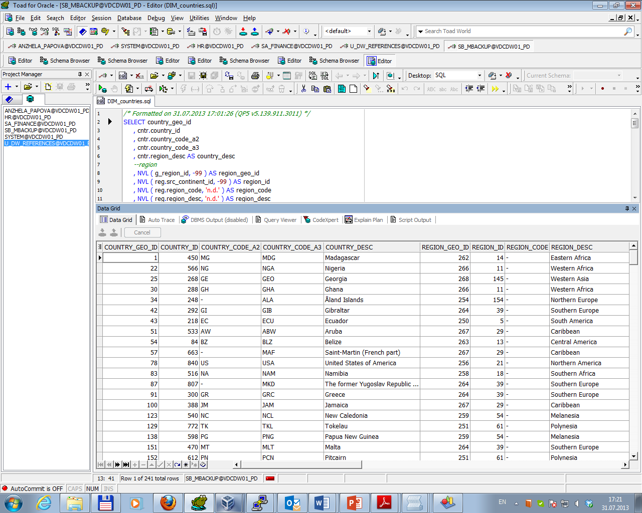

Script in attached file Hier_analitic.sql was created to analyze Geo types hierarchy by identifying their types (Branch, Root, Leaf), child counting of Branch or Root and adding path of dependencies. Result is presented below.

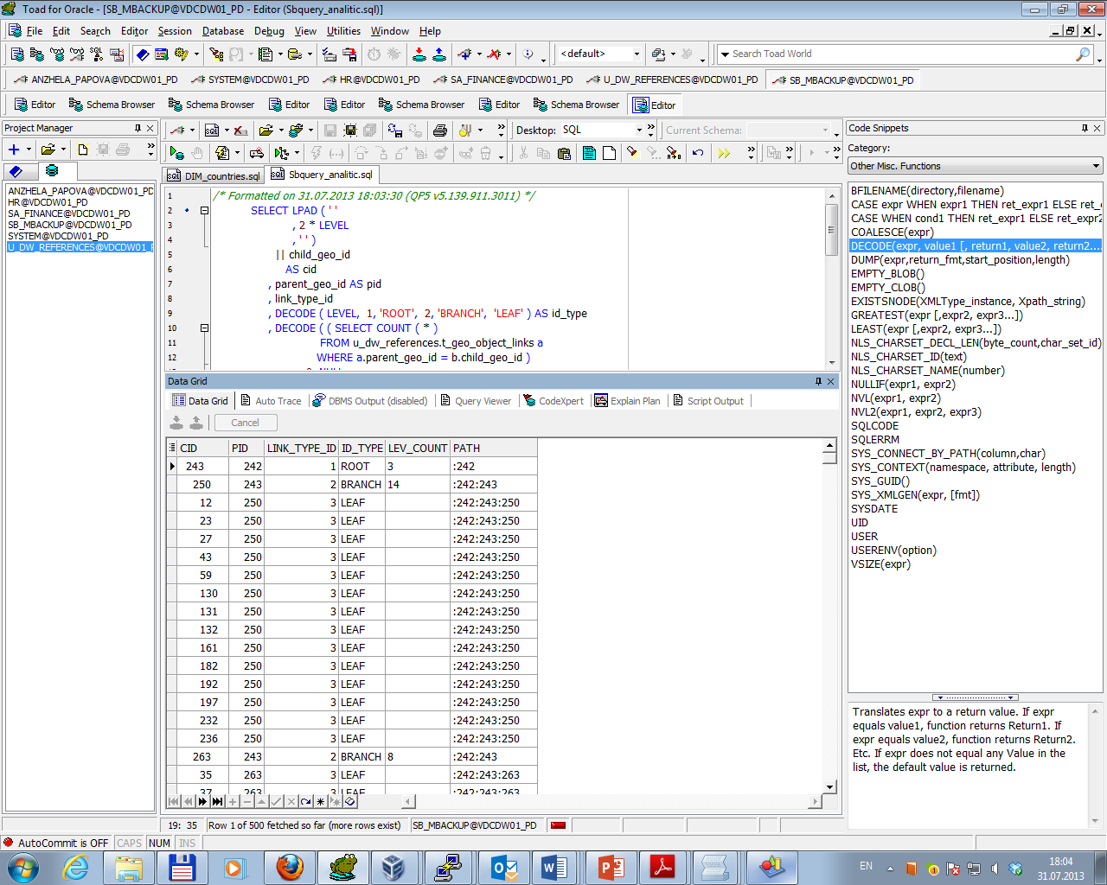

Task 02. Analyze Business hierarch Reference Analyses

As I have no hierarchy dimension except Country dimension I’ve created sample of using hierarchy based on hr schema.

Script is in attached file HR_hier_analitic.sql. Result is presented below.

